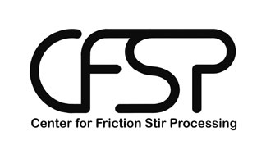 

**Mechanical and Microstructural Evaluation of Friction Stir Processed Haynes® 282® Superalloy**

*Prepared by:*

Ian Markon

*Faculty Advisors:*

Dr. Michael West

REU Program Director

Dr. Christian Widener

AMP Center Director

Dr. Bharat Jasthi

AMP Center Research Scientist

Dr. Alfred Boysen

Professor, Department of Humanities

*Program Information:*

National Science Foundation

Grant **#0852057**

Research Experience for Undergraduates

Summer 2011

South Dakota School of Mines and Technology

501 E Saint Joseph Street

Rapid City, South Dakota

**Table of Contents**

**Abstract** ……………………………………………………........................... **3**

**Introduction** ……………………………………………………...........................  **3**

**Broader Impact** ……………………………………………………........................... **4**

**Procedure** ……………………………………………………........................... **5**

**Base Material Analysis** ……………………………………………............... **5**

**Material Processing** ……………………………………………........................... **7**

**Results** ……………………………………………………........................... **11**

**Processing** ……………………………………………………........................... **11**

**Microstructural** ……………………………………………........................... **11**

**Mechanical** ……………………………………………………........................... **21**

**Discussion** ……………………………………………………........................... **23**

**Conclusion** ……………………………………………………........................... **24**

**Summary** ……………………………………………………........................... **24**

**Future Work** ……………………………………………........................... **25**

**References** ……………………………………………………........................... **26**

**Acknowledgments** ……………………………………………........................... **27**

**Abstract**

Haynes® 282®, a new γʹ strengthened, nickel-based superalloy developed by Haynes International, is intended for use in high temperature applications related to both air and land-based gas turbines. Friction Stir Processing (FSP), a new materials processing technique invented by The Welding Institute, is used by the power turbine industry. Attempts are being made to combine Haynes 282 with FSP to allow the material to be used in advanced ultrasupercritical power plants. This study attempted to evaluate the feasibility and results of Friction Stir Processing Haynes 282 by performing bead-on-plate welds in Haynes 282 plate using an MTS ISTIR-10 Intelligent Friction Stir Welder. The welds were then sectioned, heat treated, and used for metallography and microhardness samples.

It was found that FSP of Haynes 282 is indeed possible, though certain material flow issues must be addressed. Also, FSP refines the microstructure of Haynes 282 and increases its microhardness. Lastly, heat treatment lessens these beneficial results but does not erase them fully.

1. **Introduction**

Haynes 282 alloy is a recently developed, γʹ strengthened, nickel-based superalloy designed to exhibit great creep strength while still remaining fabricable. The alloy also responds well to traditional welding techniques [6] and is intended for use in high temperature applications such as aero or land-based gas turbine components. As demonstrated by Jasthi, Howard, and Arbegast [4 and 5], Friction Stir Welding/Processing may be applied to nickel-based superalloys to refine their microstructures and reduce the formation of detrimental phases such as the topologically close-packed (TCP) phases that can occur in alloys similar to Haynes 282. Glenn Grant of Pacific Northwest National Laboratory (PNNL) has partnered with this research program in an effort to determine the feasibility and effects of FSP on Haynes 282. If FSP of Haynes 282 can be proven to eliminate/reduce the formation of TCP phases in the welded material, the material may gain usage in advanced ultrasupercritical power plants.

The goal of this preliminary study is to develop FSP parameters for Haynes 282 and characterize the microstructural evolution and basic mechanical properties of the processed material. The microstructural evaluation will focus on grain size analysis while the mechanical evaluation will focus on microhardness.

To accomplish these goals, bead-on-plate welds using a tungsten-rhenium-4% hafnium carbide pin tool will be performed on 3/16” thick plates of Haynes 282 in the solution-annealed condition. These welds will establish acceptable parameters for the Friction Stir Processing of Haynes 282, and the resulting welds will yield representative metallographic and microhardness samples. The welds will also be heat treated according to the heat treatment procedure developed by Haynes specifically for 282 alloy. Finally, the heat treated samples will be examined to determine the effects of heat treatment on grain size and microhardness.

1. **Broader Impact**

As mentioned in the Introduction, Friction Stir Welding is an advanced material-joining technique that is used in the land-based turbine industry. Friction Stir Welding offers its own set of advantages and disadvantages when compared to traditional welding techniques, but, if used properly, the significant advantages of Friction Stir Welding may offset its disadvantages. These advantages include refining the base metal microstructure, ensuring homogeneous distribution of precipitates, and possibly eliminating detrimental phases. If a new method for joining Haynes 282 is developed that harnesses these advantages, power turbine designers will be given an additional tool to use in the design of high-temperature turbines. This may lead to better, more efficient turbine designs which could ultimately result in cheaper energy for consumers.

Discovering additional fabrication techniques for Haynes 282 will also increase the utility of the alloy. This increase in versatility will hopefully be followed by an increase in production and usage which in turn will hopefully create jobs related to the manufacture and processing of the material.

1. **Procedure**

**Base Material Analysis**

Upon receipt of 0.1875” x 4.125” x 10” plates of wrought Haynes 282 from PNNL, a small sample of material was cut out using a cut-off saw and then mounted, ground, polished, and etched for metallography. Figure 1 is a picture of one of the plates in the as-received condition.

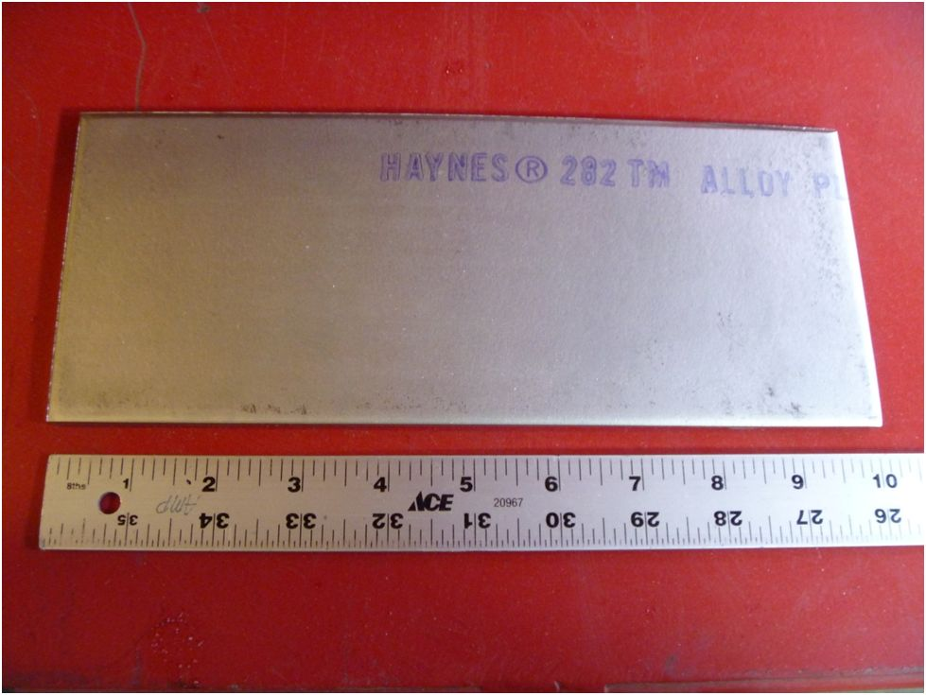

**Figure 1. As-Received Hayes 282 Plates.** (Author’s work.)

The as recieved sample was mounted in LECO® Black Bakelite Powder, and grinding was performed using successively finer grits of silicon-carbide paper (80, 240, 400, 600, and 1200 grit). Polishing was then performed using 3 micron LECO Ultra Diamond Suspension for 4 minutes at 200 RPM followed by a final polish using 1 micron diamond suspension and identical polishing speed and time.

The polished sample was then etched by immersion for approximately 1 minute in a mixture of 15 mL HCl, 10 mL acetic acid, and 10 mL HNO3. The sample was rinsed with water following etching and dried with compressed air. The finished specimen was observed for microstructure and grain size, and Vickers microhardness measurements were performed. These preparation/testing procedures were followed for all subsequent metallography/microhardness samples as noted below.

**Material Processing**

Once the base material had been characterized, trial bead-on-plate welds were performed on one of the 282 plates using an MTS ISIR-10 Intelligent Friction Stir Welder equipped with a Megastir cooling head and an argon shroud. The welds were made using a tungsten-rhenium-4% hafnium carbide pin tool (see Figure 2 for pin tool details) and several weld parameters were varied in attempts to produce fully-consolidated, defect-free welds. During all six trial welds, the rpm’s were held constant at 200 and the plunge depth was fixed at 0.145.” Forge control mode was also used for all welds, and each weld was 3” long. As one final note, the pin tool was slightly worn prior to performing welds 1 and 2; it was re-machined before the remaining welds were performed. Table I lists the parameters that were varied between the welds, and Figures 3, 4, and 5 show the clamping, the welding, and the plate after welding, respectively.

**Table I. Haynes 282 Weld Parameter Map.** Thee inch long welds made in forge control mode at 200 rpm’s with a plunge depth of 0.145.” (Author’s work.)

|  |  |  |  |  |  |  |
| --- | --- | --- | --- | --- | --- | --- |
| Weld | 1 | 2 | 3 | 4 | 5 | 6 |
| Forge Force  (pounds) | 5,000 | 5,000 | 6,000 | 6,000 | 6,000 | 6,000 |
| Travel Speed (ipm) | 2.0 | 2.0 | 2.0 | 1.0 | 0.75 | 0.5 |
| Lead Angle  (degrees) | 1.0 | 1.0 | 1.0 | 1.0 | 2.0 | 2.0 |
| Defect Type | Wormhole | Lack of Consolidation | Lack of Consolidation | Flow-Arm Feature | Flow-Arm Feature | Flow-Arm Feature |



**Figure 2. Tungsten-Rhenium-4% Hafnium Carbide Pin Tool Technical Drawing.** (Photo courtesy of the Arbegast AMP Center.)

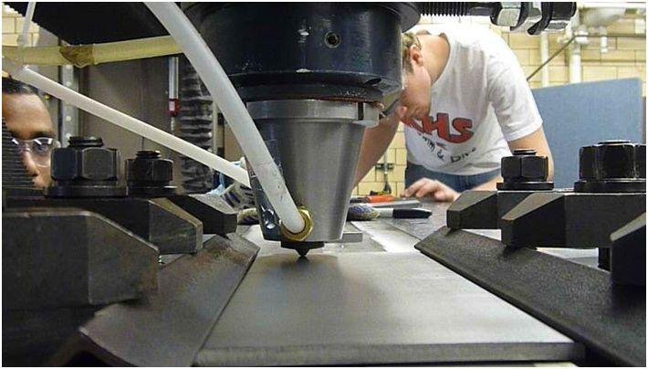

**Figure 3. Weld Set-Up and Clamping.** (Author’s work.)

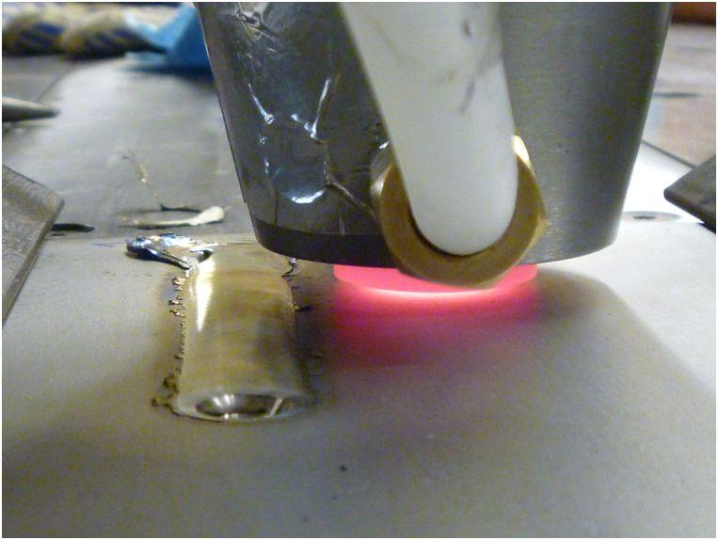

**Figure 4. Mid-Weld.** (Author’s work.)

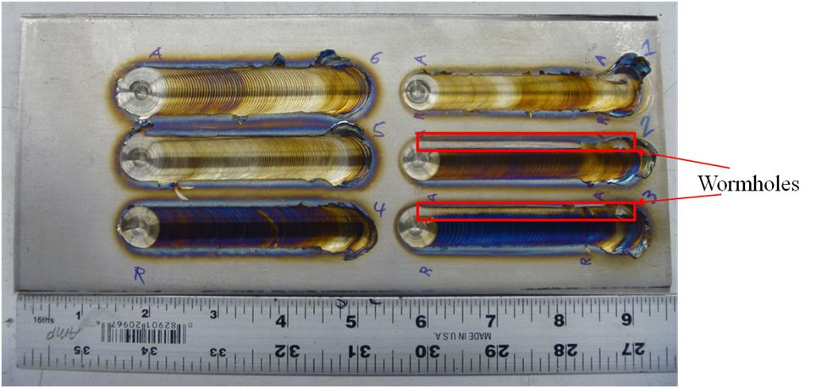

**Figure 5. As-Welded Haynes 282 Plate.** An argon shroud was used in an attempt to minimize surface oxidation. (Author’s work.)

Welds 4, 5, and 6 were then sectioned, and two metallographic samples were prepared from each weld. One sample from each weld was examined in the as-welded condition while the other was examined following the standard, two-step aging treatment for Haynes 282: 1850°F (1010°C)/2 hours/air cool + 1450°F (788°C)/8 hours/air cool [4]. Both the as-welded and heat treated samples were examined by means of optical microscopy, and the ASTM grain size number and Vickers microhardness profile of each sample were determined.

As a brief note on the metallography of the welded and/or heat treated samples, an additional polishing step using 6 micron diamond suspension (200 rpm, 4 min) was deemed necessary. Also, the heat treated samples etched faster than the solution annealed samples, requiring only 20 seconds of immersion in the etchant.

1. **Results**

**Processing**

None of the welds were defect free, but the severity of the defects present lessened greatly from weld 3-6. Welds 1-3 all exhibited wormhole defects of varying severity while welds 4-6 all exhibited possibly less detrimental flow-arm features. The flow-arm features steadily shrank in size from weld 4 to weld 6. Figure 6 shows macrographs of welds 4, 5, and 6 to illustrate the shrinking flow-arm feature.

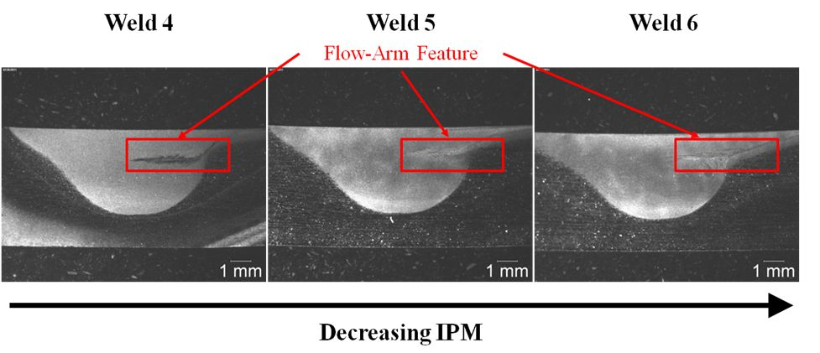

**Figure 6. Shrinking Flow-Arm Feature.** Note that the flow arm feature is not a void. (Author’s work.)

**Microstructural**

The initial metallography from the as-received plates indicated that the material was indeed in the easily-fabricable, solution-annealed condition. The average ASTM grain size for the material in this condition was found to be ASTM 4.9 with an average grain diameter of 59.4 µm. Figure 7 shows a representative micrograph of solution-annealed Haynes 282.

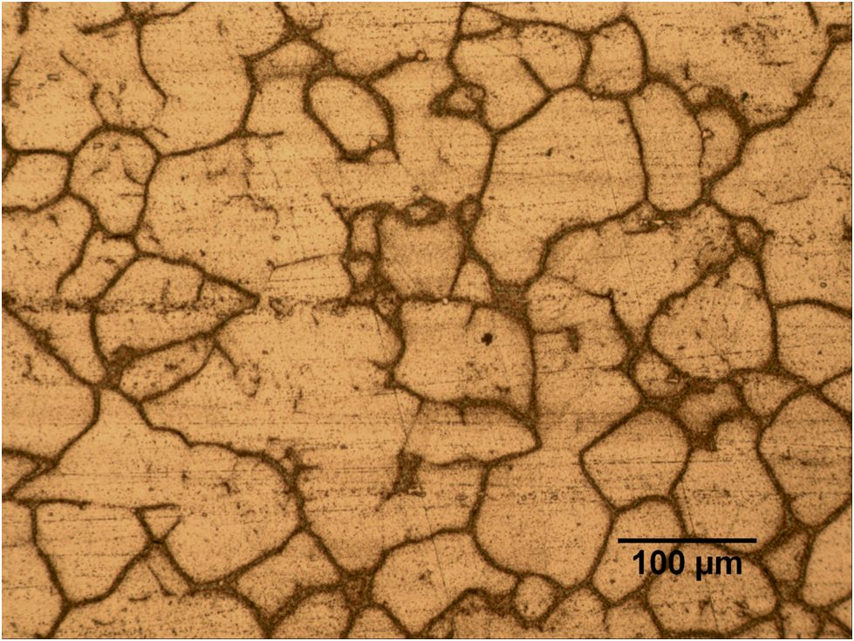

**Figure 7. Microstructure of As-Recieved Haynes 282.** The sample was etched by immersion for approximately 1 minute in a mixture of 15 mL HCl, 10 mL acetic acid, and 10 mL HNO3. (Author’s work.)

Friction Stir Processing produced a very marked change in the microstructure of the as-welded metallography samples. The grains in the nugget region were greatly refined, possessing an average grain diameter about ten times shorter than the average grain diameter of the parent material grains. Figure 8 illustrates the drastic reduction in grain size.

Also of some note is the twinning that appears so prevalent outside of the weld nugget. At first, this twinning was not observed in the as-received metallography sample, but a closer examination leads one to believe that this apparent absence is most likely an artifact of etching. No twinning was observed in the weld nugget region by optical microscopy, but SEM observation will be needed to confirm this.

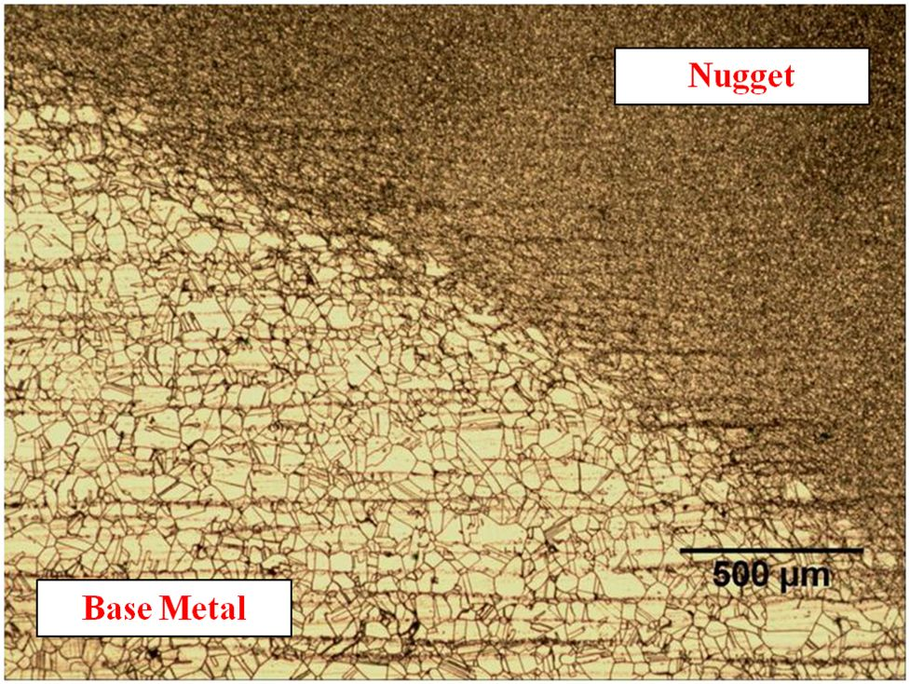

**Figure 8. Weld 6 Retreating Nugget Edge.** The average grain diameter outside of the nugget was 53 ± 6 µm (ASTM 5.3 ± 0.4) while the average grain diameter inside the nugget was 4.3 ± 0.5 µm (ASTM 12.4 ± 0.3). Note the large amount of twinning outside of the weld nugget. (Author’s work.)

Figures 9, 10, 11, 12, and 13 show representative micrographs taken from the as-welded samples.

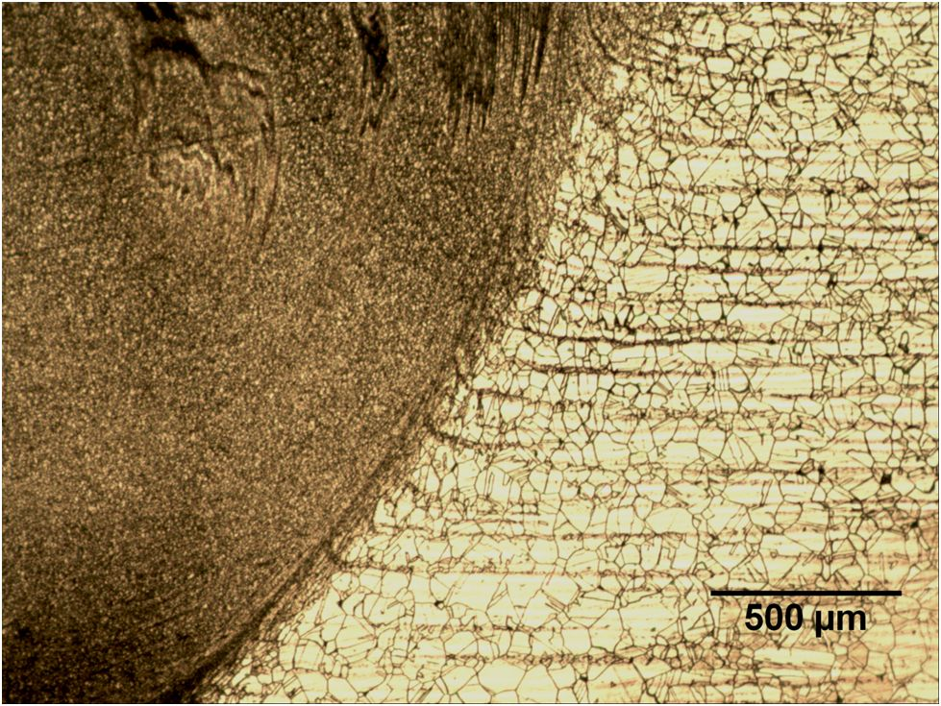

**Figure 9. Weld 6 Advancing Nugget Edge.** (Author’s work.)

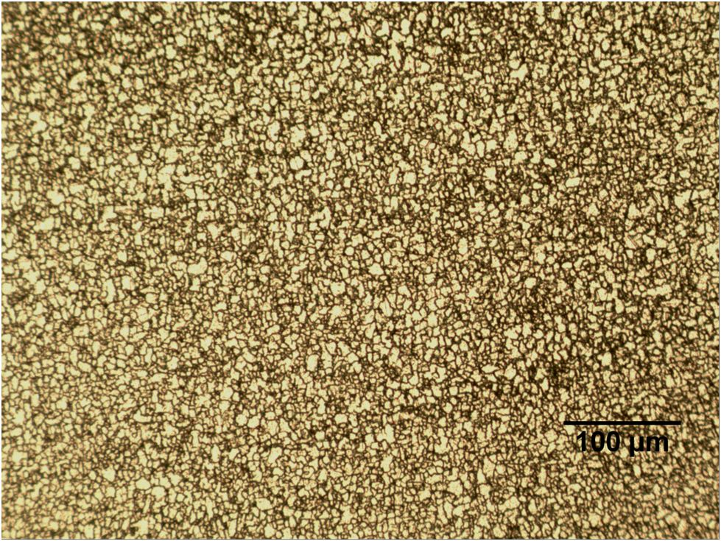

**Figure 10. Weld 6 Nugget.** (Author’s work.)

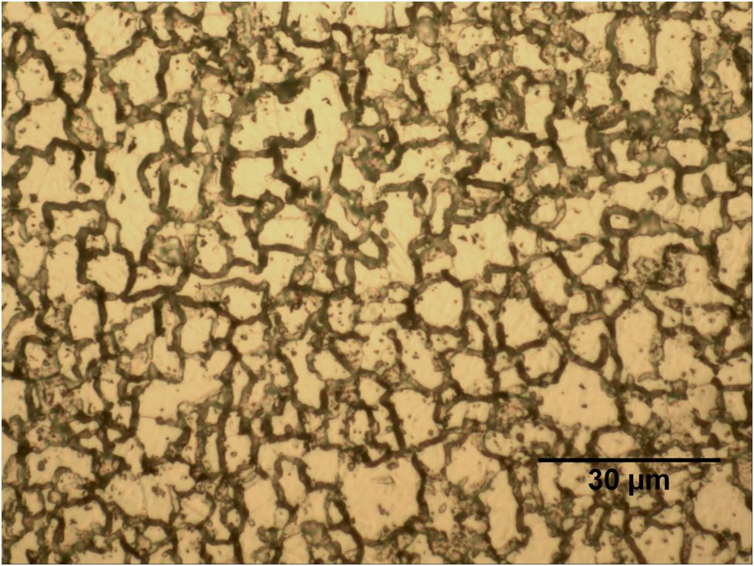

**Figure 11. Weld 6 Nugget High Magnification.** (Author’s work.)

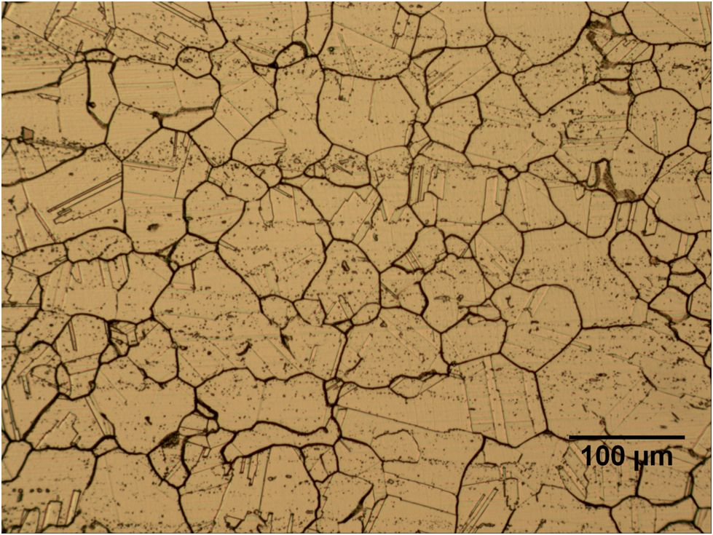

**Figure 12. Weld 6 Base Metal.** (Author’s work.)

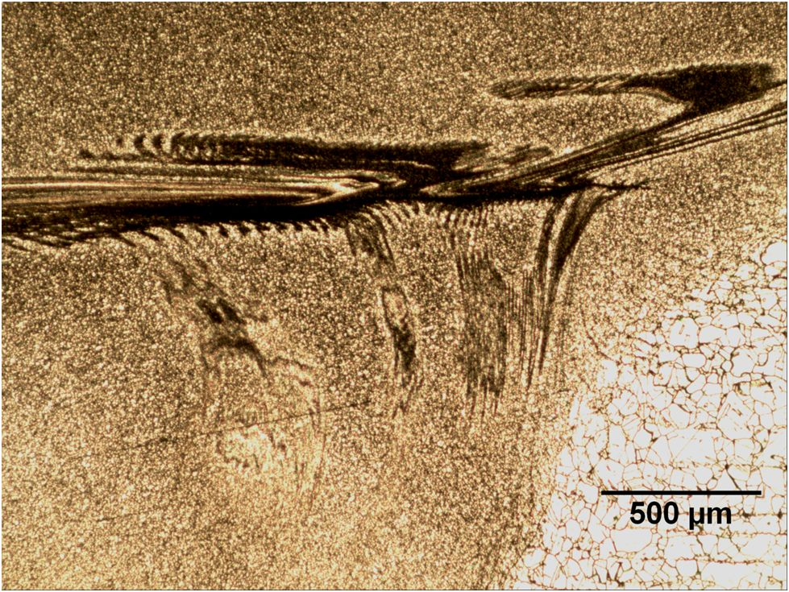

**Figure 13. Weld 6 Flow-Arm Feature.** (Author’s work.)

Heat treatment also produced some changes in the microstructure of the material. A change in grain size was only noticeable in the nugget region of the welded samples, however, and no grain growth was observed in a sample of Haynes 282 that experienced heat treatment but no welding. In the nugget regions of the welded samples, abnormal grain growth occurred with the result that the grains near the center of the stir zone exhibited much more grain growth than the grains in the vortex of the stir zone. Table II summarizes the grain size data collected, and Figure 14 illustrates the abnormal grain growth observed.

**Table II. Grain Size Data.** Note that difficulties with the weld 4 + HT sample prevented grain size data from being acquired for that sample. Also, grain size readings were not taken from the vortex region of weld 5 + HT because the general trend in grain size was all that was required from that sample.

|  |  |  |  |  |  |
| --- | --- | --- | --- | --- | --- |
|  | **ASTM** | **Average Diameter (µm)** |  |  |  |
| **Parent** | 4.9 ± 0.3 | 59 ± 7 |  |  |  |
| **Parent + HT** | 4.9 ± 0.2 | 59 ± 5 |  |  |  |
|  |  |  |  |  |  |
|  | **ASTM** | **Average Diameter (µm)** |  | **ASTM** | **Average Diameter (µm)** |
| **Location:** | **Nugget Center** |  |  | **Vortex** |  |
| **Weld 4** | 13.2 ± 0.1 | 3.3 ± 0.1 |  | 13.2 ± 0.1 | 3.3 ± 0.1 |
| **Weld 5** | 12.9 ± 0.2 | 3.7 ± 0.3 |  | 12.9 ± 0.2 | 3.7 ± 0.3 |
| **Weld 6** | 12.4 ± 0.3 | 4.3 ± 0.5 |  | 12.4 ± 0.3 | 4.3 ± 0.5 |
| **Weld 4 + HT** | N/A | N/A |  | N/A | N/A |
| **Weld 5 + HT** | 8.0 ± 0.3 | 20.2 ± 2.6 |  | N/A | N/A |
| **Weld 6 + HT** | 6.5 ± 0.4 | 33.3 ± 4.1 |  | 11.2 ± 0.4 | 6.6 ± 0.8 |

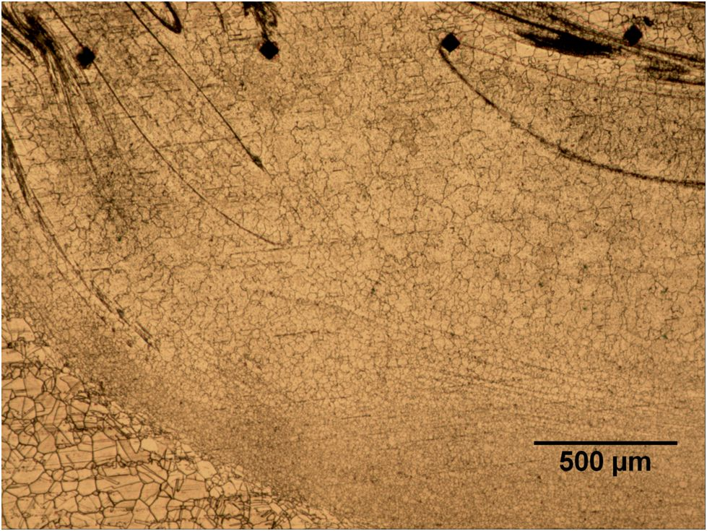

**Figure 14. Abnormal Grain Growth in Weld 6.** Note how much smaller the grains in the vortex region (ASTM 11.2, ~6-7µm average diameter) remained when compared to the grains more towards the center of the stir zone (ASTM 6.5, ~33µm average diameter). (Author’s work.)

**Mechanical**

As a further test to characterize the starting condition of the Haynes 282 plates, Vickers microhardness measurements were performed on the as-received material. The average hardness value was found to be 195.0 HV, indicating that the material was in a fairly soft condition. These measurements also provided a baseline for further microhardness measurements.

Microhardness measurements for each material condition were later taken and compiled in Figure 15. Friction Stir Processing was seen to greatly increase the hardness of the material prior to heat treatment and only slightly increase the hardness of the material after heat treatment.

**Figure 15. Haynes 282 Microhardness.** The parent metal (i.e. the solution annealed 282) possessed an average microhardness of 195 HV and the heat treated parent metal possessed an average microhardness of 339 HV. The highest value measured was 384 HV in the nugget of weld 4.

1. **Discussion**

The weld defects present in all of the welds appear to be the result of insufficient material plasticization. So far, increasing the heat input of the welds by reducing travel speed has seemed to help with material plasticization problems.

The grain size refinement and microhardness measurements in the Friction Stir Processed Haynes 282 appear to be closely linked. This is perhaps best illustrated in the slight decrease in as-welded microhardness from the weld 4 nugget to the weld 6 nugget. Weld 4 experienced the lowest heat input of the final three welds while weld 6 experienced the greatest heat input, resulting in a gradually increasing grain size from weld 4 to weld 5 to weld 6. The greater heat input likely gave the hotter welds more energy for grain growth. These trends are illustrated in Table III.

**Table III. Trends in As-Welded Microhardness and Grain Size.** (Author’s work.)

|  |  |  |  |
| --- | --- | --- | --- |
|  | Weld 4 | Weld 5 | Weld 6 |
| Travel Speed  (ipm) | **1.0** | **0.75** | **0.5** |
| Nugget Grain Size  (microns) | **3.30** | **3.72** | **4.34** |
| Nugget Microhardness  (average HV) | **347.3** | **335.9** | **323.0** |

The majority of the hardening effect seen after heat treatment is the result of γʹ precipitation, but even then the grain refinement in the nugget (though much less now) is likely responsible for the slight increase in hardness observed between the nugget and the parent material. Improved distribution of precipitates is also a possibility, but SEM or TEM work will be required to test this hypothesis.

As a last note of discussion, the abnormal grain growth in the nugget region following heat treatment may possibly be avoided if improved Friction Stir Processing parameters are developed that better plasticize the material. The reasoning behind this statement is that abnormal grain growth is often caused by non-uniform strain throughout the grains of a metal. In light of the material plasticization problems encountered, it seems reasonable that this proposed non-uniform strain distribution may be the result of material flow problems. Further experimentation with weld parameter development will hopefully clarify this issue.

1. **Conclusion**

**Summary**

Much work remains to be done in order to characterize the effects of Friction Stir Processing on Haynes 282 superalloy, but the initial results indicate that Friction Stir Processing is possible and potentially beneficial. Material plasticization issues seem to be the key difficulty that must be overcome for effective Friction Stir Processing of the alloy, but a slow travel speed seems to help alleviate this problem. The two key benefits of Friction Stir Processing Haynes 282 are a refined microstructure and increased microhardness, both of which remain after heat treatment, albeit in a less dramatic form.

**Future Work**

Defect free welds must be obtained in order for the project to move forward. Additional bead-on-plate welds will be performed in Haynes 282 plates, and welding temperature will be monitored with thermocouples. Parameters will be varied as necessary to produce high-quality welds.

To fully understand the microstructural changes that result from the Friction Stir Processing and subsequent heat treatment of Haynes 282, scanning electron microscopy and transmission electron microscopy will be used to characterize the effects on precipitation and twinning. Also, the effect of FSP on the formation of TCP phases in Haynes 282 will be observed.

Furthermore, tensile testing of welded material will be performed in order to obtain a more useful measurement of material strength and ductility. Hardness is roughly correlated to strength, but there are phenomena on the macro scale that may influence material performance in ways that hardness measurements cannot account for. However, microhardness measurements are nondestructive and quicker and easier to perform than tensile testing, so microhardness measurements were ideal for the scope of this report.

Lastly, less generic material testing, such as corrosion or creep testing, is expected in the future. This material performance information seems to be pertinent considering the material’s intended usage in hot, corrosive conditions.

**References**

1. Boehlert, C.J., & Longanbach, S.C. (2011). A comparison of the

microstructure and creep behavior of cold rolled Haynes® 230 alloy and Haynes® 282 alloy. *Materials Science and Engineering A*, *528*(15), 4888-4898.

1. Chirieleison, G., et al. (2009). The effect of aging heat treatments on

the mechanical properties of gamma prime strengthened nickel based superalloy weld metal. *Proceedings of the 8th international conference on trends in welding research* (pp. 140-148). Materials Park, OH, USA: ASM International.

1. Jasthi, B.K., Howard, S.M., & Arbegast, W.J. (2011) Friction stir

processing of cast Inconel 718. *Friction stir welding and processing-VI* (pp. 25-32). Edited by R.S. Mishra, et al. The Minerals, Metals and Materials Society.

1. Jasthi, B.K., Howard, S.M., & Arbegast, W.J. (2011) Friction stir

processing of alloy 22. *Friction stir welding and processing-VI* (pp. 11-18). Edited by R.S. Mishra, et al. TMS.

1. Ojo, O.A., & Ghoneim, A. (2011). Microstructure and mechanical

response of transient liquid phase joint in Haynes 282 superalloy. *Materials Characterization*, *62*(1), 1-7.

1. Pike, L.M. (2008). Development of a fabricable gamma-prime (γ′)

strengthened superalloy. *Proceedings of the 11th international symposium on superalloys, superalloys 2008* (pp. 191-200). Warrendale, PA, USA: The Minerals, Metals and Materials Society.

1. Pike, L.M. (2007). Low-cycle fatigue behavior of Haynes® 282® alloy

and other wrought gamma-prime strengthened alloys. *Proceedings of the 2007 asme turbo expo* (pp. 161-169). New York, NY, USA: American Society of Mechanical Engineers.

1. Pike, L.M., & Srivastava, S.K. (2008). Oxidation behavior of wrought

gamma-prime strengthened alloys. *Proceedings of the 7th international symposium on high temperature corrosion and protection of materials* (pp. 661-671). Stafa-Zuerich, Switzerland: Trans Tech Publications Ltd.

**Acknowledgments**

The author would like to thank the Center for Friction Stir Processing and the National Science Foundation for providing the funding for this research. Special thanks are also due to Glenn Grant and PNNL for generously providing the sheets of material used in this study and for providing project guidance. More thanks are due to Dr. West, Dr. Widener, Dr. Jasthi, and everyone else at the Arbegast Advanced Materials Processing Center for their help and advice on this project. Lastly, but certainly not least, the author would like to thank Dr. Boysen for his guidance in the writing of this paper and the rest of the REU staff for all of the time and effort that they have put into this program.